**NBS PLUS CONTROL ROOM**

**Maintenance**

I conducted a maintenance of computers in NBS sport through clearing browsers, configuring startup programs, cleaning keyboards, mouse and computer units, blowing and dusting off, etc.

Below are some of the pictures taken while doing maintenance of computers in NBS Sport control room

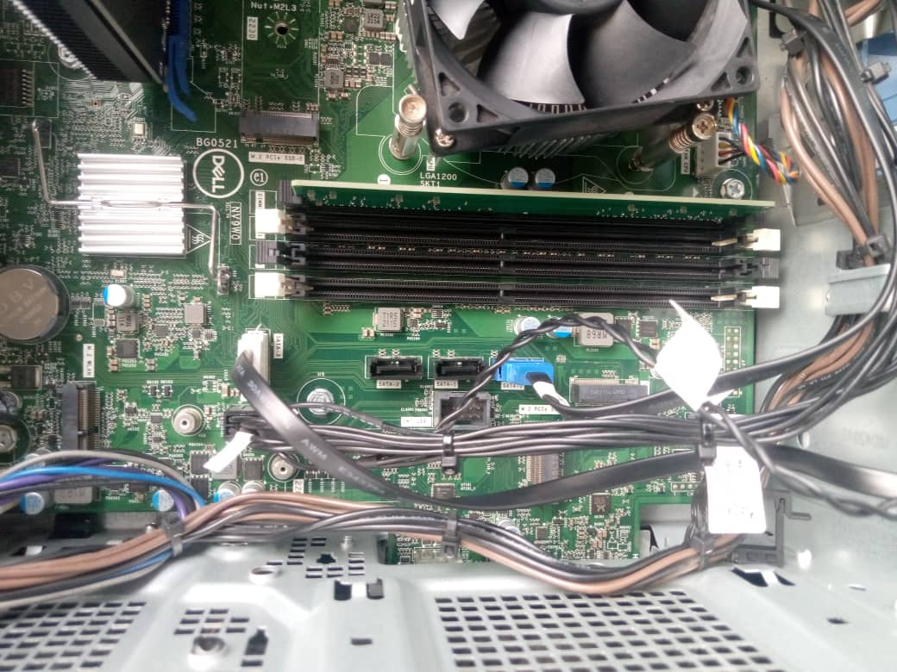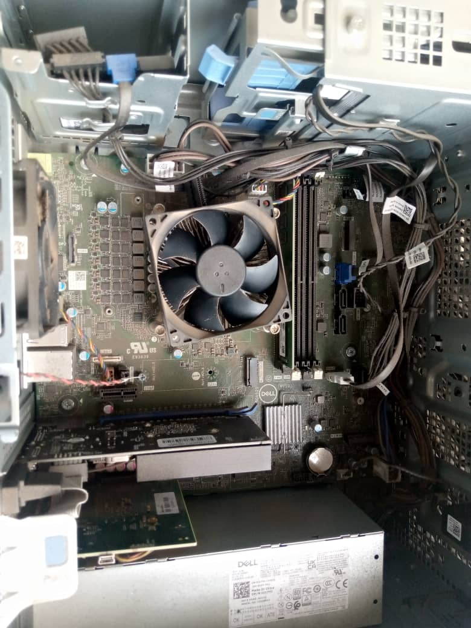**Before**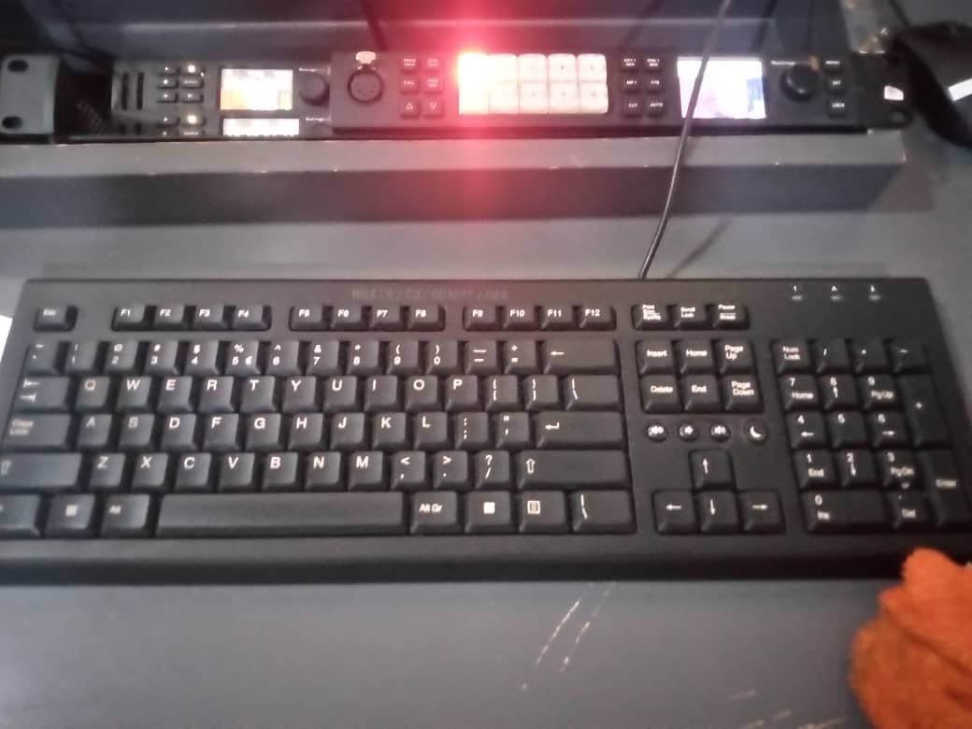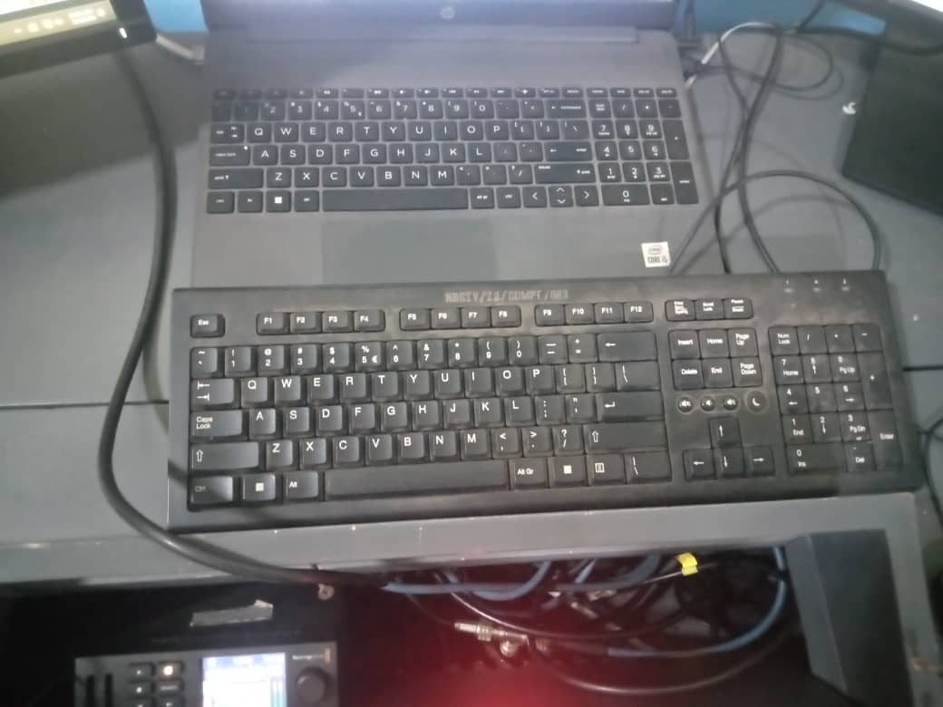

All computers are working well in NBS PLUS control room